February 5, 2009

Your Worship Mayor Kelly
Councillors
Dan English, COO
Ken Reashor, Traffic & Right of Way Department

Following is a Report with respect to the trial crosswalk flag project currently in existence along Waverley Road, in Dartmouth.

We appreciate your attention to what we believe has been a successful initiative to improve crosswalk safety.

It is our understanding that in order to even consider expanding the program beyond the Waverley Road location, the flags need to be approved as traffic control devices by the Transportation Association of Canada (TAC) and the Province of Nova Scotia.

Our request at this time is for the appropriate group, which we assume to be the Traffic & Right of Way area, to make a request to the TAC and Province of Nova Scotia for approval. We look forward to working with the Traffic & Right of Way team to share the experiences and learnings of the particular flags we have used.

Should flags be approved as a traffic control device we are hopeful Council will then consider budget in order to expand the program.

Again, thank you for your time and consideration of this important safety initiative.

Sincerely yours,

Gayle Collins
Norm Collins
Brian Slaunwhite

… be Cautious … be Seen … be Safe

Waverley Road Crosswalk Flags

A Report on the Trial Project of Flags At Crosswalks
Along Waverley Road, Dartmouth, Nova Scotia

… be Cautious … be Seen … be Safe

Trial Project Highlights

- trial project implemented in August 2008 at 13 marked crosswalks along Waverley Road in Dartmouth
- trial project funded by Councillor Younger and 13 local businesses/individuals
- cost of trial project $2,550 or < $200 per crosswalk
- theft, while initially high has since stabilized (over the past eight weeks) at only 2 per week or < 0.3 flags per day
- survey input very strong with respect to flags being noticed, expansion throughout HRM, and a willingness to pay for an expansion
- evidence/feedback that vehicles stop more frequently and more timely when flags are used, than when not
- feedback that drivers are more aware of the upcoming crosswalk due to the existence of the eye level brightly coloured flags
- cost to expand across HRM estimated at $100,000 per year

Submitted February 5, 2009

Brian Slaunwhite Gayle Collins Norm Collins

Index

1. Background … page 2
2. Media coverage … page 4
3. The Program, Its Cost and Funding … page 4
4. Experience … page 5
Use … page 5
Theft … page 5
Driver reaction … page 6
5. Feedback … page 6
Survey … page 6
Results of the survey … page 7
Verbatim feedback … page 8
6. Context … page 9
7. Next Step(s) … page 9

Background

A couple of years ago two teenagers were killed in crosswalk incidents in Dartmouth. As a result considerable attention was directed to crosswalk safety, including the publication of a very useful pamphlet by HRM titled ‘Crosswalk Safety in Halifax Regional Municipality”. As well the Government of Nova Scotia appointed a Joint Crosswalk Safety Task Force in April 2007. The Task Force finalized and released their Report in April 2008. While including a number of recommendations, very few related to the visibility of crosswalks. One recommendation that did was to provide eye-level amber lights at five crosswalks in HRM. Seven months later, at least at the two Dartmouth crosswalks the eye-level amber lights have yet to be installed.

At the same time, in March 2008, a small community group in an effort to tangibly improve crosswalk safety approached Councillor Andrew Younger with a request to implement a crosswalk flag program on Braemar Drive, Waverley Road and Andover Street (in front of Michael Wallace Elementary School), similar to programs in Salt Lake City, Utah, Seattle, Washington and a number of other US cities. To the best of the group’s knowledge no similar program exists elsewhere in Canada.

In response to the request the HRM Traffic & Right of Way, while not endorsing the program, agreed “… to take no action to remove the buckets or flags unless legitimate complaints of safety hazards are received”

After also receiving approval from Nova Scotia Power and Aliant to attach buckets to their poles the buckets and flags were put in place August 7, 2008 at 13 crosswalks, 12 along Waverley Road and one on Andover Street in front of Michael Wallace Elementary School.

… be Cautious … be Seen … be Safe 2 www.waverleyroadcrosswalkflags.synthasite.com

The Buckets

Each crosswalk has a bucket on each side of the road, attached to the pole displaying the crosswalk sign. The buckets are white 4” PVC pipe with holes drilled in a bottom cap in order to allow rainwater to drain. Each has a decal briefly describing the program and process for crossing. The buckets have proven to be quite functional as flags have not fallen out, or blown out during significant wind storms.

The Flags

Each crosswalk has 12 bright orange flags. The flags are 15” x 15” attached to a 27” dowel. On each side of the flag is placed a 1” stripe of reflective tape to enhance visibility, particularly at night. For promotion, and to strive to minimize theft each flag has the words ‘Property of Waverley Road Crosswalk Flags’ on one side and ‘... be Cautious … be Seen … be Safe’ on the other

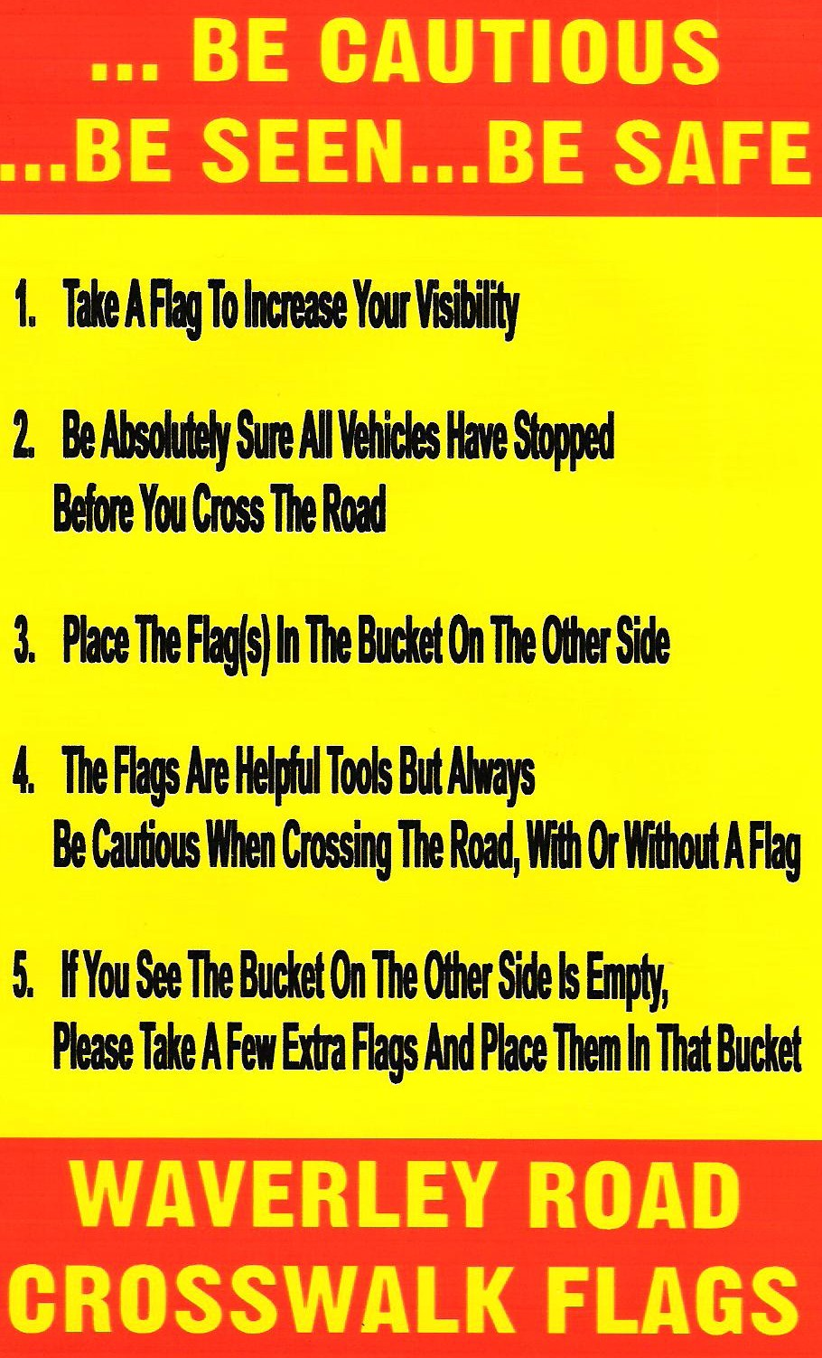
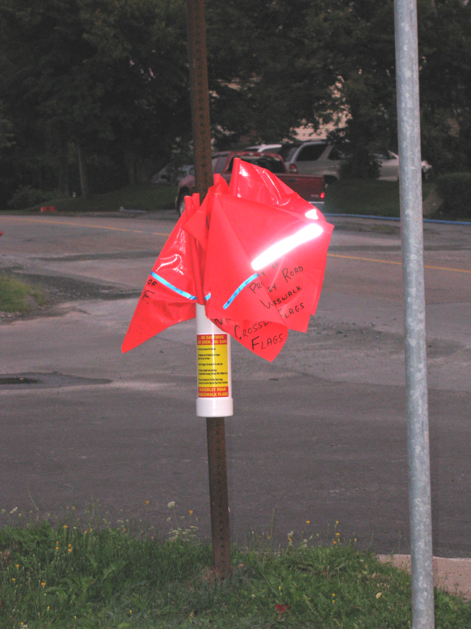

Visibility

In addition to the opportunity for pedestrians to use the flags when crossing the road it has been noted the flags, even if not used, add visibility and awareness to drivers of the upcoming crosswalk. In particular, during the winter months when the white crosswalk signs become less visible as they blend into the surrounding snow, the bright orange flags are especially noticeable.

Communication

A brochure describing the program was prepared and delivered to 2,300 residences in the neighbourhood.

As well a website (www.waverleyroadcrosswalkflags.synthasite.com) explaining the program was published.

… be Cautious … be Seen … be Safe 3 www.waverleyroadcrosswalkflags.synthasite.com

Media coverage

The launch of the Crosswalk Flag program received considerable media attention, including

- Halifax News Net – News – June 16, 2008
- CBC Mainstreet – August 11, 2008
- CBC News.ca – August 11, 2008
- CBC TV – 6:00 pm news – August 12, 2008
- Halifax Chronicle Herald – August 15, 2008
- Halifax News Net - Rick Howe blog – August 18, 2008
- Halifax News Net - Rick Howe column – August 22, 2008
- Halifax News Net – News – August 22, 2008
- District 6 email update – a number of references to the program
- CBC Mainstreet – re-airing of portions of the August 11, 2008 interview – November 24, 2008

While much of the media attention focused on the thefts, the old adage that ‘any media attention is good media attention’ no doubt applies.

The Program, Its Costs and Funding

The program is simple and relatively inexpensive.

A bucket is attached to a pole on either side of each crosswalk, in which are placed six (6) bright orange flags. Pedestrians may carry a flag while crossing the road in order to increase their visibility. Each flag has reflective tape on both sides to provide additional visibility. In an effort to reduce theft each flag has been marked with ‘Property of Waverley Road Crosswalk Flags’ on one side and the message ‘… be Cautious … be Seen … be Safe’ on the other side.

The cost of the trial program to date has been $2,573.93, or just under $200 per location.
Costs have been

$1,568.29 460 flags, or $3.41 per flag
$ 427.14 reflective tape, or $0.93 per flag
$ 139.88 hardware for buckets
$ 153.11 photocopying and administrative supplies/costs
$ 285.51 delivery of 2,300 brochures to neighbourhood

$2,573.93 total cost

The trial project has been funded by the generous support of Councillor Younger and a number of businesses* along the Waverley Road. Contributions total $2,720.00.

* A.R.T.S Trophy House, Collins Financial Consulting, Collision Repair Association of Nova Scotia, Conrad Brothers, Grasshoppers, J&W Whebby Enterprises, Independence Beauty Centre, Kaleidoscope Café & Bakery, Michael Wallace Home & School, Tim Horton’s, Waverley Road Health Care, Waverley Road Pharmasave and two residents

… be Cautious … be Seen … be Safe 4 www.waverleyroadcrosswalkflags.synthasite.com

Experience

Use

Indications are that less than 15% of pedestrians use the flags (Chapel Hill, Salt Lake City). Anecdotal evidence indicates experience may not be dissimilar along Waverley Road. That acknowledged, it is often observed the number of flags on one side of the road are considerably greater than on the other side, evidence the flags are indeed being used. It has been also been observed and reported by the Principal at Michael Wallace Elementary School that student use the flags on a regular basis. On the other hand there has been feedback from a few who completed the recent survey that observed “I have never seen anyone cross with a flag”

Theft

The most significant concern encountered when launching the program was the expected level of theft. Theft was anticipated, and experienced, particularly in conjunction with the launch of the program.

The following charts, by week, the number of flags missing at the 13 crosswalks. After the first two weeks the level of theft has more or less stabilized at 0.86 flags per day. During the past eight weeks the average as dropped to 2 flags per week, or 0.3 flags per day.

The initial supply of flags used a 3/4 “ wooden dowel. In a number of cases the dowel was removed but the flag left. A smaller second supply of flags with a 3/8 “ nylon dowel were purchased. These have been tested at four crosswalks with an equal number (six) of wood and nylon doweled flags supplied each week. Since introduction of the nylon doweled flags 20 have gone missing – 12 of which were wood dowels and 8 were nylon.

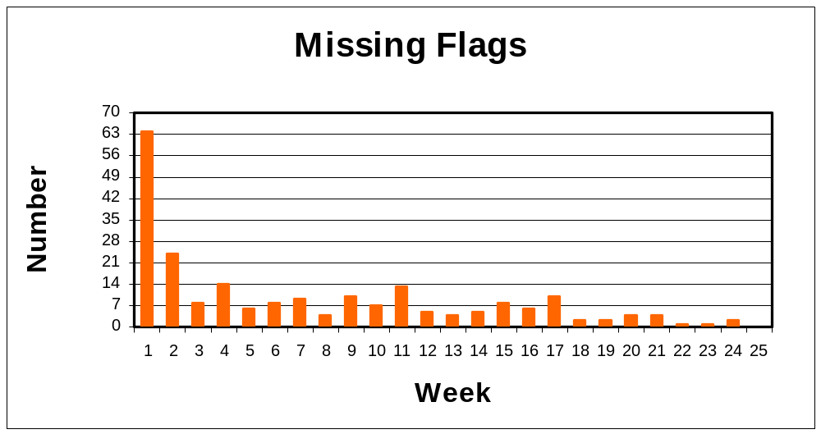

… be Cautious … be Seen … be Safe 5 www.waverleyroadcrosswalkflags.synthasite.com

Driver Reaction

Based on the anecdotal experience of the team member who re-stocks the buckets each week the perception is that drivers do stop more frequently when a flag is used than when they are not. In order to test this perception the individual crossed Waverley Road at Ellis Court 15 times with and without a flag between 3:30 and 4:00 pm Saturday, November 29, 2008. The results of this test indicate vehicles do stop more frequently when flags are held and waved by a pedestrian than when that is not the case.

When a Flag was Carried - in 11 of the 15 crossings, or 73 % the first car stopped*. In only one case did two vehicles pass before one stopped.

When No Flag was Carried – in only 8 of the 15 crossings, i.e. 53 %, did the first car stop. In two cases two vehicles passed before one stopped, and in a third case three vehicles passed before one stopped.

* based on the pedestrian’s judgement as to whether the vehicle had a reasonable amount of time to stop

Feedback

Survey

After four months the Crosswalk Flag team developed a short survey to solicit input:

1. Do you regularly travel along the Waverley Road? Yes _____ No _____

2. Have you noticed the crosswalk flags along Waverley Road? Yes _____ No _____

3. How effective do you believe the crosswalk flags are at improving crosswalk safety?

0 1 2 3 4 5 6 7 8 9 10
Useless Very effective

4. Do you believe the program should be expanded across HRM? Yes _____ No _____

5. ‘Yes’ would you be prepared to pay an increased tax of
on average $1 per household per year? Yes _____ No _____

Basis for the Average $1 per household cost per year

Councillor Younger provided data that in 2007 there were 502 marked crosswalks under the control of HRM. Based on an extrapolation of the trial project’s experience, at a cost of $200 per crosswalk per year the annual cost is forecast to be more or less $100,000. The 2008-2009 HRM Budget provides (pages C18 and C19) that there are 105,234 residences in HRM, the basis of the on average $1 per residence cost to maintain the program.

… be Cautious … be Seen … be Safe 6 www.waverleyroadcrosswalkflags.synthasite.com
The surveys were distributed

- through Councillor Younger’s monthly email update
- through Michael Wallace elementary school, and

in person in front of Tim Horton’s (Waverley Road) and Kaleidoscope Café & Bakery between
10:15 am and 12:15 pm on Saturday, November 29, 2008

Results of The Survey

A total of 92 responses were received

… of those 85, or 92 % noticed the flags

… of those 82, or 96 % are of the view the program should be expanded across HRM

… of those 79, or again 96 % are prepared to pay an increased tax to expand the program.

Question | Yes | No | % Yes
Have you noticed the flags? | 85 | 7 | 92 %
Should the program be expanded across HRM? | 82 | 3 | 96 %
Are you prepared to pay an additional tax to expand the program? | 79 | 3 | 96 %

In terms of effectiveness, results ranged from 4 to 10, with Very Effective (10) being the most common response. Over half assessed the effectiveness as either a 9 or 10. The average ‘effectiveness’ score was 8.2.

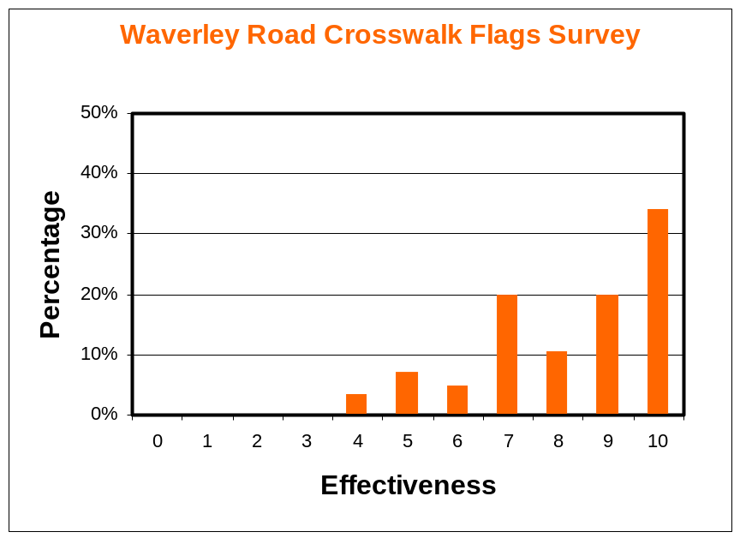

… be Cautious … be Seen … be Safe 7 www.waverleyroadcrosswalkflags.synthasite.com

A number of those who rated the effectiveness relatively low commented the flags did not appear to be used often. Others however noted that whether or not the flags were being used, their existence creates greater awareness of drivers. Drivers observed they were cognizant of the crosswalks much sooner as a result of the flags than was the case prior to the existence of the flags.

Verbatim Feedback

A number of observations on the program were received, some unsolicited and others in conjunction with the survey.

“I am both a driver and a pedestrian. When I am driving the bright flags quickly draw my attention to crosswalks. When I'm walking and using a flag I feel safer because I know I am more visible.”

“I cannot recall having seen a more simple and affordable idea have such a positive impact on pedestrian safety.”

“Simple yet effective idea! As a driver, there is no confusion if a pedestrian is attempting to cross the road. The visible flags work. As a pedestrian … crossing is easier with the high visibility flags. I think the flags are better than the flashing crosswalk lights. Those lights are too high to be effective.”

“I have travelled and lived on the Waverley Rd. for the past 36 years and the crosswalks stand out merely because of the flag containers. Come to think of it I've never actually seen a flag used but certainly have been made more aware of the crosswalks by the bundles of orange flags.”

‘The flags do bring attention to the crosswalks and make drivers more aware.”

The ‘cautious’, and only negative feedback was in respect of usage and thefts.

“It may not work in high crime areas or in the downtown, but certainly for mainly residential areas where there are heavy flow traffic routs they are extremely useful.”

“This ingenious idea would only work in "Neighbourhood" areas and not in the "core" areas where flags would be mistreated or stolen.”

“I use the road daily and have only seen the flags used once. My opinion is that they are not used and therefore not needed by the majority of people. It has become a waste of tax dollars.”

… be Cautious … be Seen … be Safe 8 www.waverleyroadcrosswalkflags.synthasite.com

Context

Crosswalk safety is multi-faceted issue. There are many initiatives that will improve safety at marked, non-intersection crosswalks, including among others

- education, directed at both pedestrians and drivers
- stiffer consequences for the contributors to accidents
- more diligent policing re those who fail to stop for pedestrians
- improved, or different, i.e. red vs. amber, lighting, both overhead and at eye level
- improved road markings, either zebra stripes, or alternative colouring
- rumble strips
- crosswalk flags

Crosswalk flags are certainly not a panacea for crosswalk safety. However they are a relatively inexpensive means of improving visibility and thereby improving crosswalk safety. The Waverley Road Crosswalk Flag team demonstrated a program:

- can be quickly implemented
- is relatively inexpensive, and
- is effective

Next Step(s)

After the initial experience of significant flag thefts the program has been effective. Based on the experience of the trial and the number of marked, non-intersection crosswalks in HRM the cost to expand the program across HRM is relatively small. Equally important is the fact it is a cost taxpayers appear prepared to spend to improve crosswalk safety. Beyond the obvious improvement to the visibility of pedestrians and the crosswalks, implementation of a program would demonstrate leadership of HRM on an important issue of public safety. Based on the media attention to the trial project one would expect significant attention, locally, provincially and perhaps nationally.

We have been advised that in 2007 there were 502 marked, non-intersection crosswalks under the control of HRM. After the initial investment to produce the buckets, including decals, and the increased incidence of flag thefts anticipated during the initial weeks after implementation, it is forecast the ongoing cost to be < $100,000 per year, based on the ongoing experience of 6 missing flags per week at the 13 trial locations. This assumes similar theft experience in other areas of HRM as the trial location.

… be Cautious … be Seen … be Safe 9 www.waverleyroadcrosswalkflags.synthasite.com

We appreciate there are issues to be considered, including:

- standards with respect to the flags, buckets and decals. Is orange the optimal colour, or would yellow be better, as some have suggested and some other programs in other US cities use? It is understood there may be national transportation standards that would need to be considered in determining the size, material, colour etc. of the flag, the length and material of the dowel and the design of the bucket. Decal wording also needs to be considered.
- extension of approval by Nova Scotia Power and Aliant for use of their poles
- pre-printing of the messages on the flags. Currently a Waverley Road Crosswalk Flag volunteer is marking each flag individually.
- the process of stocking the buckets with replacement flags. Currently a Waverley Road Crosswalk Flag volunteer checks and re-stocks the 13 locations once a week. Either HRM maintenance would need to be charged with this responsibility, or a network of volunteers, likely solicited through the schools would need to come forward to volunteer to re-stock buckets in their neighbourhood. If so, a few locations would likely need to exist throughout HRM where replacement flags would be available to the volunteers.

It is our understanding that before Traffic & Right of Way will even consider recommending expansion of the program the flags need to be approved as traffic control devises by both the Transportation Association of Canada and the Province of Nova Scotia.

It is our request that an application be made to the Transportation Association of Canada and the Province of Nova Scotia to approve a form of crosswalk flag as a traffic control device. Should approval be received it would then be requested that Council consider providing budget in order to expand the crosswalk flag program to all marked, non-intersection crosswalks throughout the HRM.

Submitted in the interests of crosswalk safety

… be Cautious … be Seen … be Safe 10 www.waverleyroadcrosswalkflags.synthasite.com

